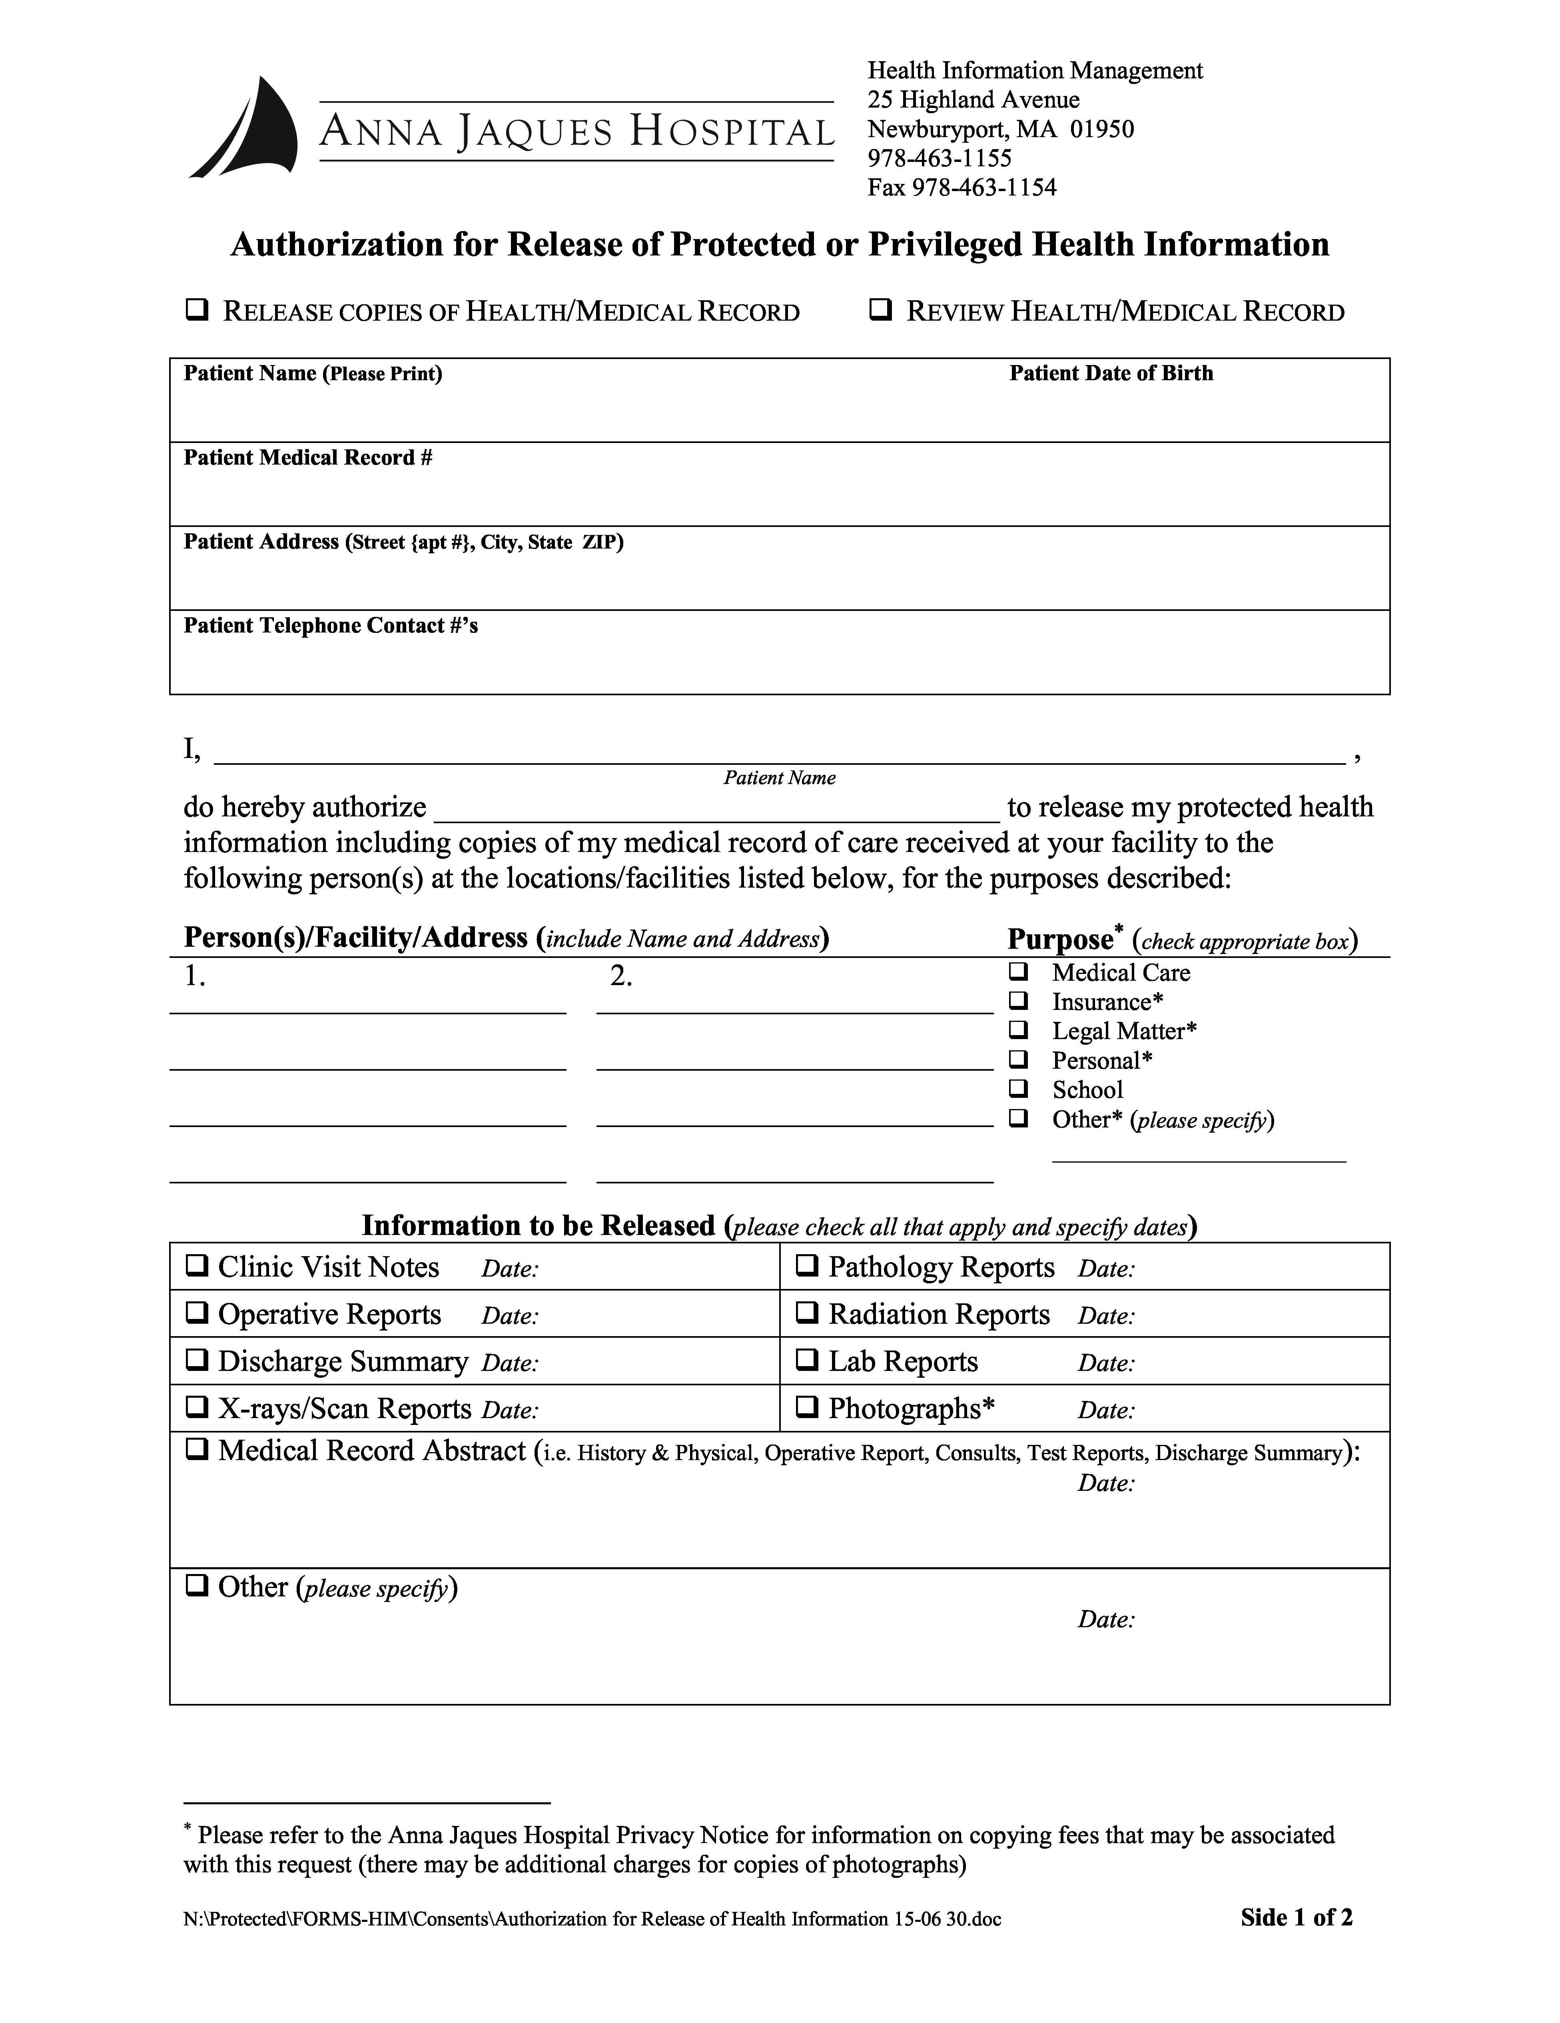
Batman

Secret Location Under Office Building, Gotham, NJ

Batman
University of Michigan Hospital and Health Center
01/01/1979
Axiom Requisition Copy Service
2869 Jolly Road
Okemos, MI 48864
PH: (877) 886-5090
✓

✓

FROM 01/01/1979 TO PRESENT: Any and all MEDICAL RECORDS, including but not limited to patient history form(s), reports, etc. pertaining to Batman SSN: xxx-xx-5555, DOB: 01/01/1979.

Order No. 01-29018-002

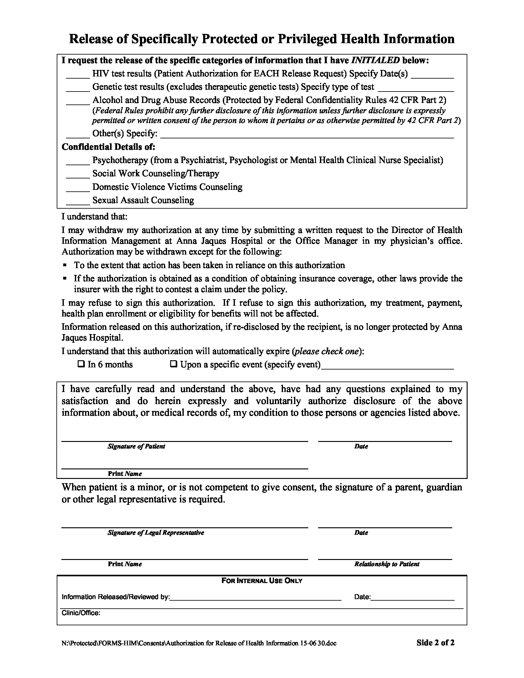
✓

End of Litigation

